**Meta Programming is the writing of computer programs that write or manipulate other programs (or themselves)**

**Meta Object Protocol (MOP)**

“The MOP is a collection of rules of how a request for a method call is handled by groovy runtime system and how to control the intermediate layer”

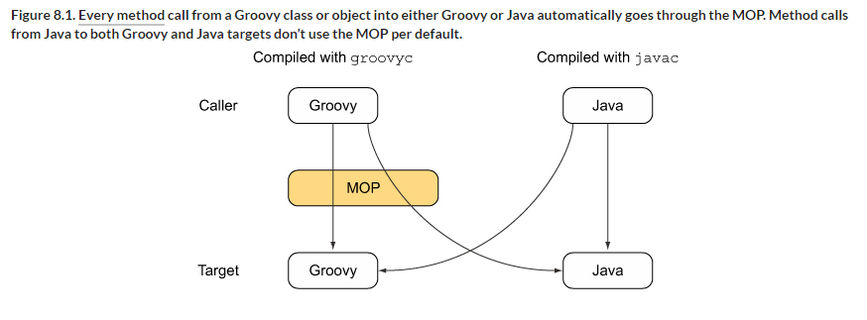

So, if we are having call from groovy then we could be dealing with three different type of objects:

* **POJO:** A regular java object, whose class can be written in java or any other language for JVM.
* **POGO:** A Groovy object, whose class is written in Groovy. It extends java.lang.Object and implements the groovy.lang.GroovyObject interface by default.
* **Groovy Interceptor:** A Groovy object that implements the groovy.lang.GroovyInterceptable interface and has method interception capability.

